Crabwings

The Northrepps Aerodrome and Aero Club newsletter

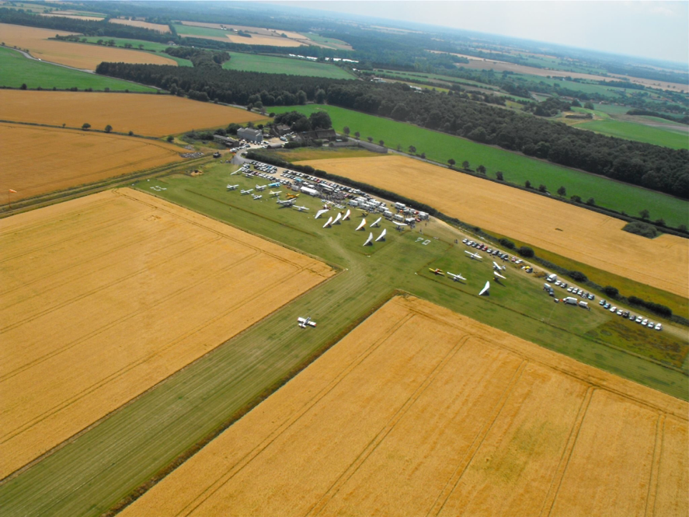
Hello and welcome to the latest news. We hope you like the new format and can now do it on my iPad rather than firing up the old coal fired laptop. That said, I spent several hours doing a two and a half page Christmas Special and promptly managed to lose it into the ether….very frustrating for someone who is not good with tech stuff….
November has not seen the best of weather and the annoying bit has been the fact that some weekdays have been fine but weekends have been horrid. That said and since the last issue, several have done first solos and others have passed some of their written exams so not all bad….. When the weather has been good, we have also seen some visitors including several “Wokkas” or Chinooks as well as the usual on going Coastguard training, mainly on the A189’s. We have also had some Apaches through but the Ospreys only seem to play after dark around here.
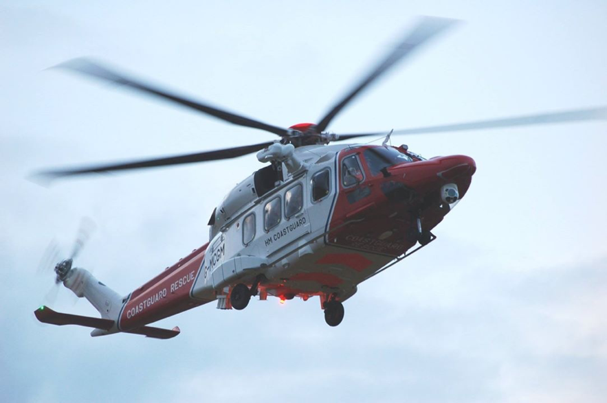
We have also been used for ‘target practice’ by both Tornados and Typhoons…all very exciting. Talking of helicopters, the sad part of the year was saying goodbye to RAF SeaKing units who after many years of gallant service, bowed out as the SAR contract was taken over by Bristow's. Many will remember them at Coltishall and I for one, owe my life to them and we owe them a huge debt of gratitude….
We have cleared a bit of the hedge on the access road to the airfield making it a lot safer and Smiffy is doing a grand job on extending the Diner. Work on the new hangar is on hold until the new year.

Following a few break-ins at one or two airfields, we have ‘upped’ the security and club members/hangar tenants have the details.
We will, as usual, be having our New Years Day Fly-in and the Diner will be open and fuels will be available. We will also be open over that weekend. Our Fly-in dates for next year will be out by early January.

Northrepps Aero Club has had, on the whole, a good year. Membership continues to steadily grow and the hangars are full with a growing waiting list. Several members have got new aircraft and some have or are converting from flex-wings to 3axis whilst others just need a larger toy box… Next month, I will try and get a list together of those who have done their 1st solo’s, got their license and/or got additional ratings.
Membership fees will stay the same again this year but we will have to have a small increase next year. Visitor landing fees will also stay the same but again, will have to go up next year. Due to an increase in both Insurance and rates, hangarage will have to go up by £5.00pcm. I should point out that both our membership and Hangarage is still the cheapest in E. Anglia but rates are expected to see a hike of up to 5% following the Autumn Statement so this could change…. There is no club meet at the Pub in N. Walsham in December but there is a “beer call” planned for those interested in Norwich before Christmas and in a pub or two close to the railway station, for more details see either Smiffy or Myself.
For those that made it to the Flying Show at Telford, they may have seen club member Paul H-S from TLAC giving a Lecture. There were also talks on weather and from a Bush pilot amongst others.

The Paramotor group has had a busy time and also gained members and many have done their 1st solo’s. They too are getting frustrated by the weather.

The Model Club are still flying when weather permits and are still cutting their grass.

Flight Safety I noticed in the latest Airprox Bulletin that 48% of the incidents investigated involved Drones and these are becoming a real menace. They have already been banned in many parts of the U.S. Other Countries are bringing in strict laws concerning their use include Australia. The North Norfolk District Council have also bought in a Law banning the use of Chinese Lanterns in the wake of several fires and animal deaths. Lasers also continue to be a menace and only a few days ago, a senior Captain with BA on approach to Heathrow was blinded in one eye and his retina was badly burned. It's our duty to report any of these incidents to the CAA if we are affected.

There are yet more changes on the way for various licenses and it's your responsibility to check the CAA website and make sure you're legal to fly. One point to ponder; as of now, when you take a flying medical…you'll be asked how many units you drink in a week. If your answer is more than 20(about 8pints of real ale) you will be reported to the CAA Medical Department…. You could have to be seen by a Councillor, sent to rehab or have your license pulled…..
The bunting on the cable by the 22 threshold was a bit tatty so a club member asked his mate from the National Grid for ideas….. He has put up the latest system so we wait to see if it works or lasts and if not,it will back to the bunting.

The Flying Press Run out of time and space this month but much of the space covered the build up to the Flying Show, test reports on Christmas toys and one or two new aircraft. I will do better next time.

(Local) Airfield News I see more Airfields are under threat including Insch in Scotland due to Pylons and Bourn in Cambridgeshire for what looks like car storage. There were a couple more but I can't find the magazine. Closer to home, Lt. Ellingham had their application refused but understand that they are going to appeal. Parliament are reviewing the policy concerning airfields including grass airfields being classed as Brownfield Sites suitable for development (Houses)… We hope this goes through as the DOT has suggested.

And finally If this format works, I will get started right away on the next one so it won't be so late.
Myself and the Team also take this opportunity to wish you and yours a very Happy Christmas and a prosperous and safe New Year.

Happy Landings.

30 November 2015
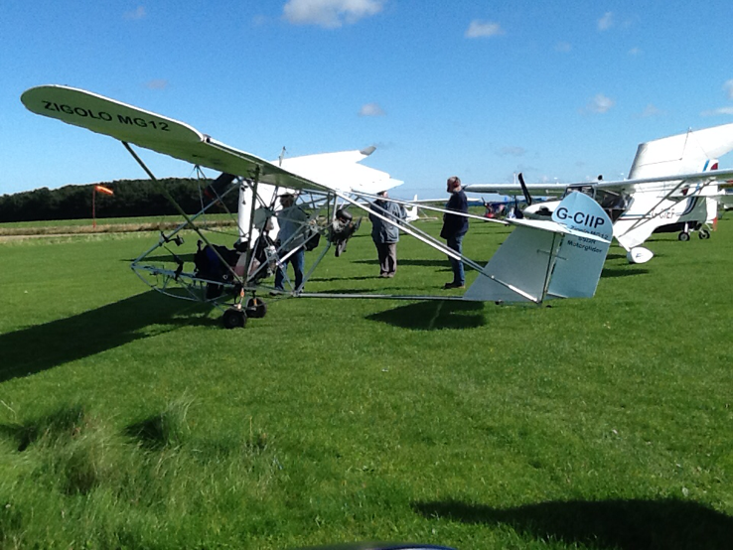
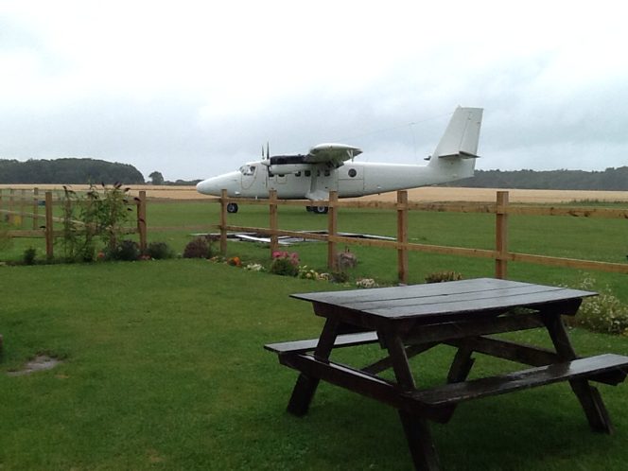

These two photos show the largest visitor (other than the Wokkas) and the smallest. The large one is a French Air Force DHC Twin Otter or Twotter and the smallest is Nic H’s Zigolo.

